**Birla Institute Of Technology and Sciences, Pilani**

**CS F241-Microprocessor Programming and Interfacing**

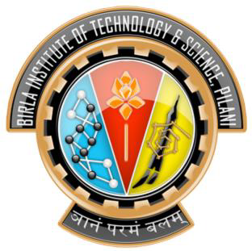

P26-Elevator Control